**APPLICANT(DEO)**

**STEP -1 :**

At first login to Service plus web portal**: (**<https://tathyasathi.bangla.gov.in/>) to apply for the **Application for Registration of Migrant Labour.**

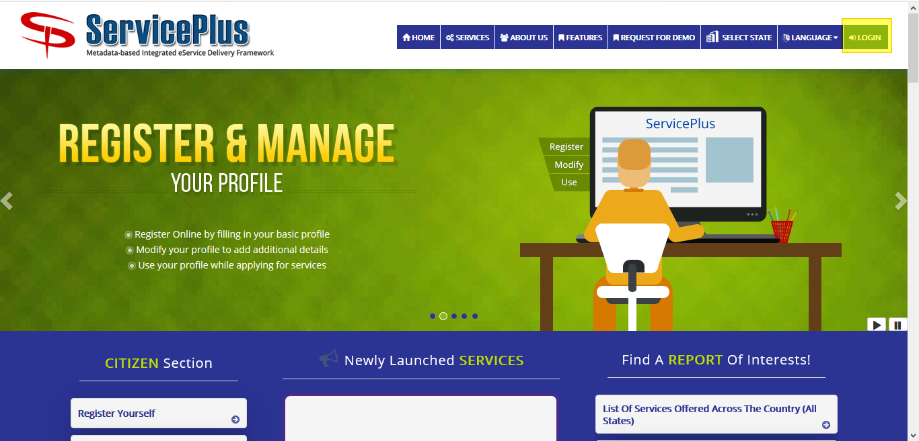

**Step -2 :**

Login as Applicant in the Service plus portal.

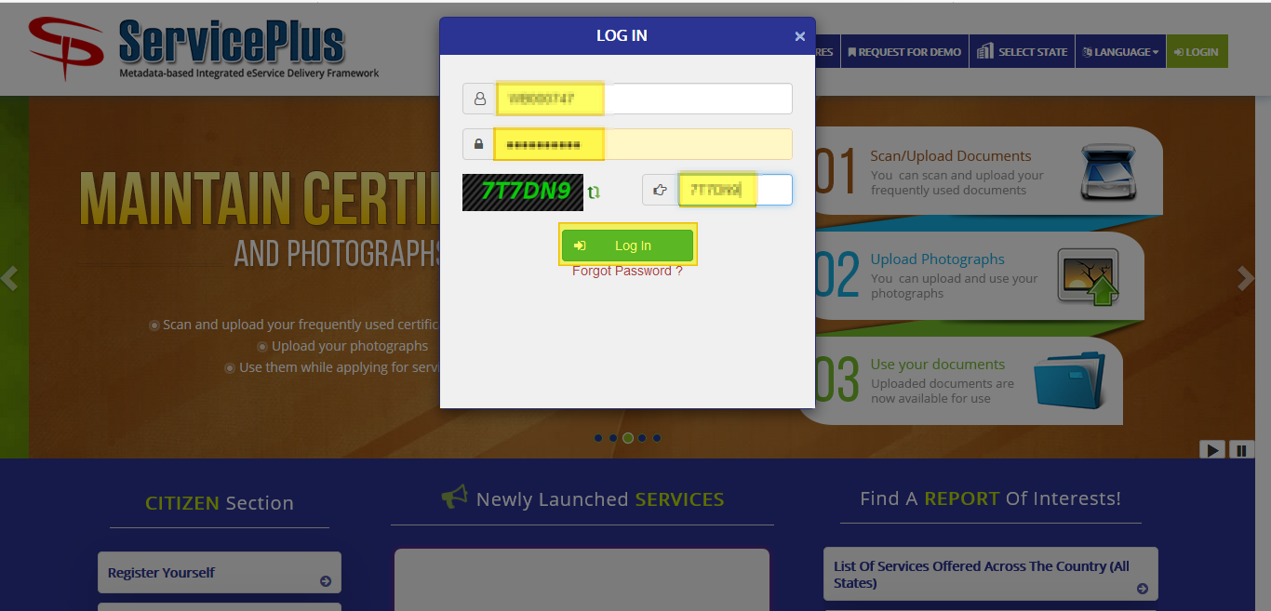

**Step -3:**

Now click “**Apply for services”** and select “**View all available services**”, then Select particular Service and Fill the form:

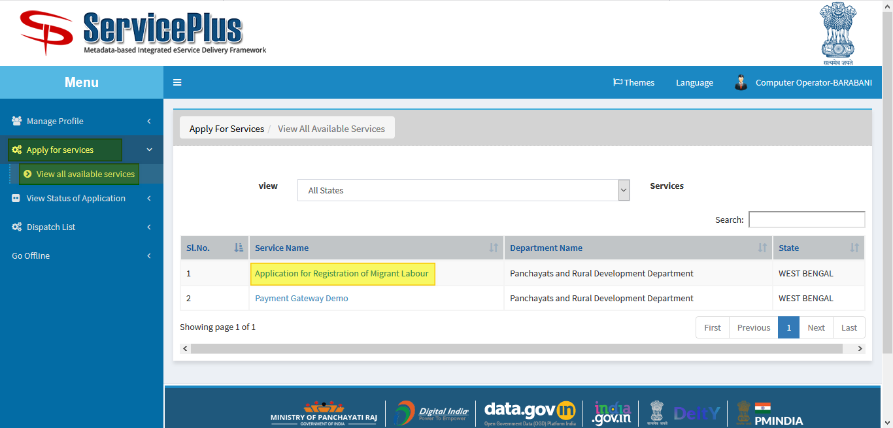

**Step -4:**

Fill the required details appropriately and match the **captcha** and **submit**.

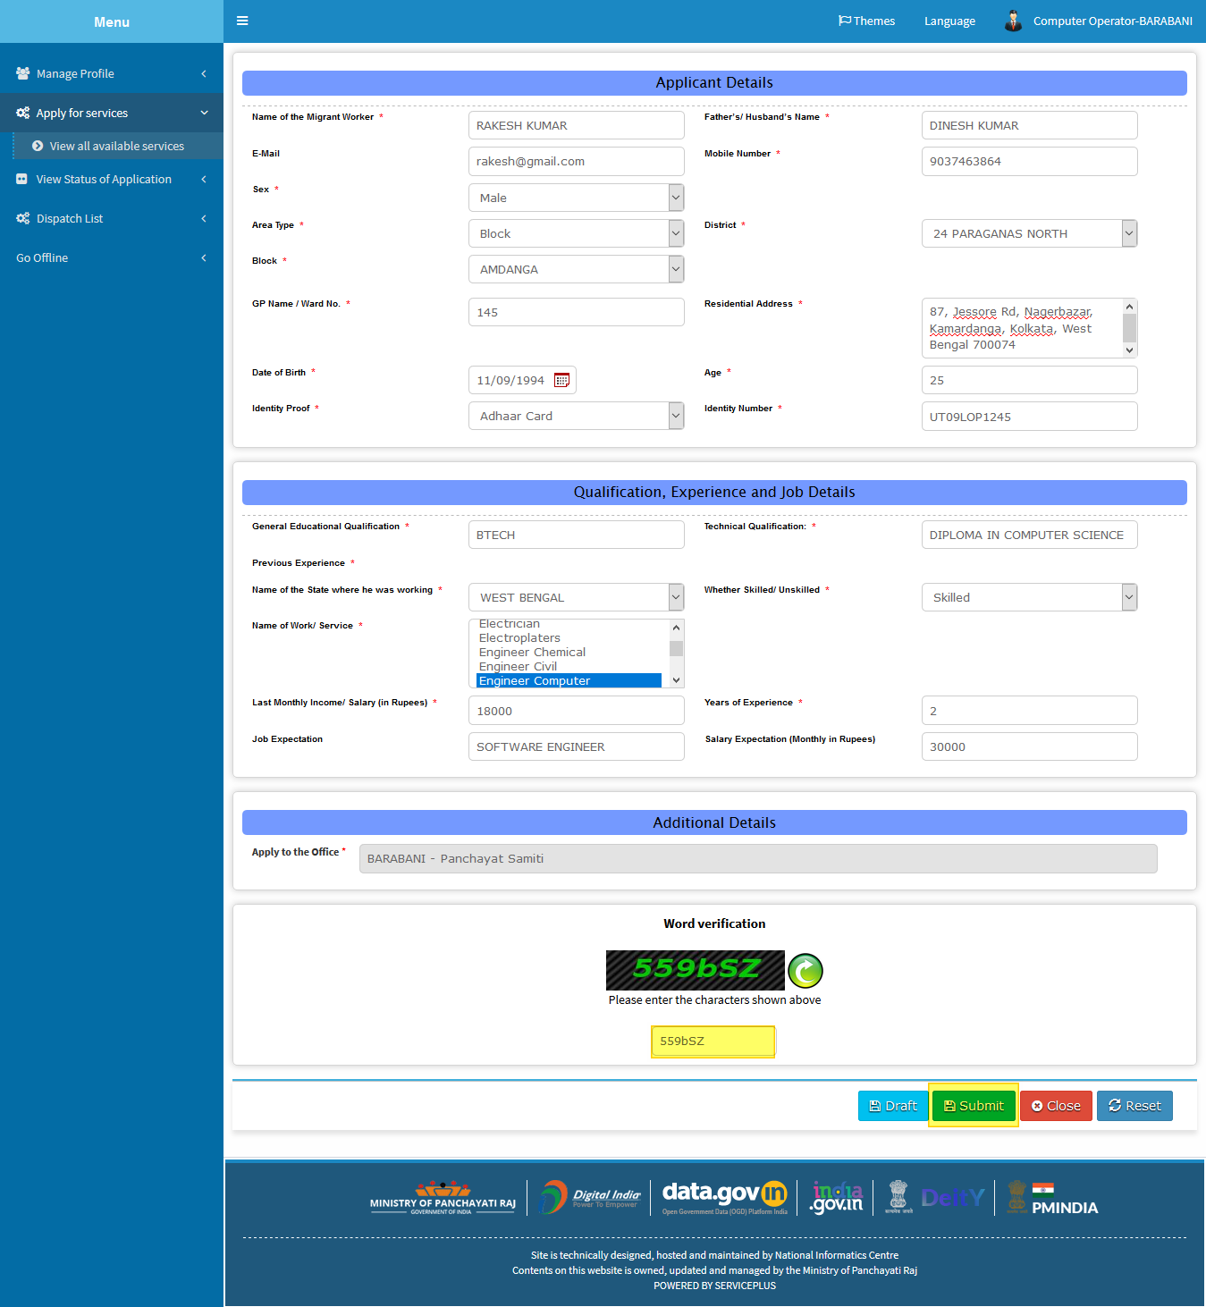

**Step -5:**

Now go through the details and click **submit**.

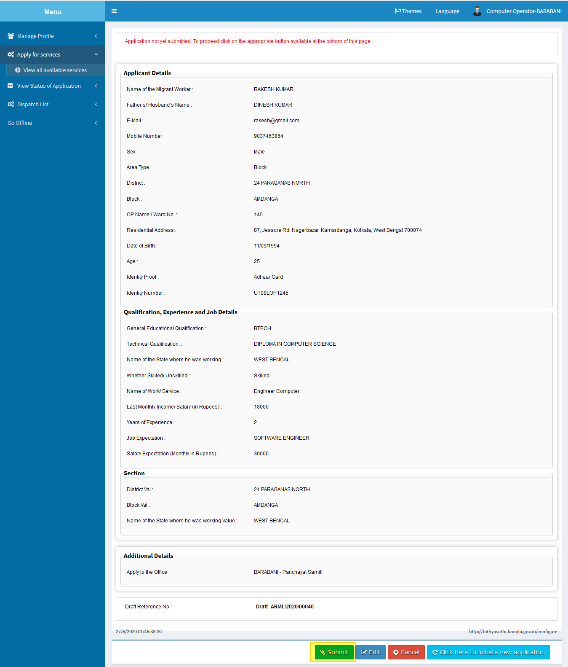

**Step -6:**

After Submission of form an acknowledgement slip is generated with **app reference number.**

Save by selecting “**Export to pdf”** or print it by selecting “**Print”**

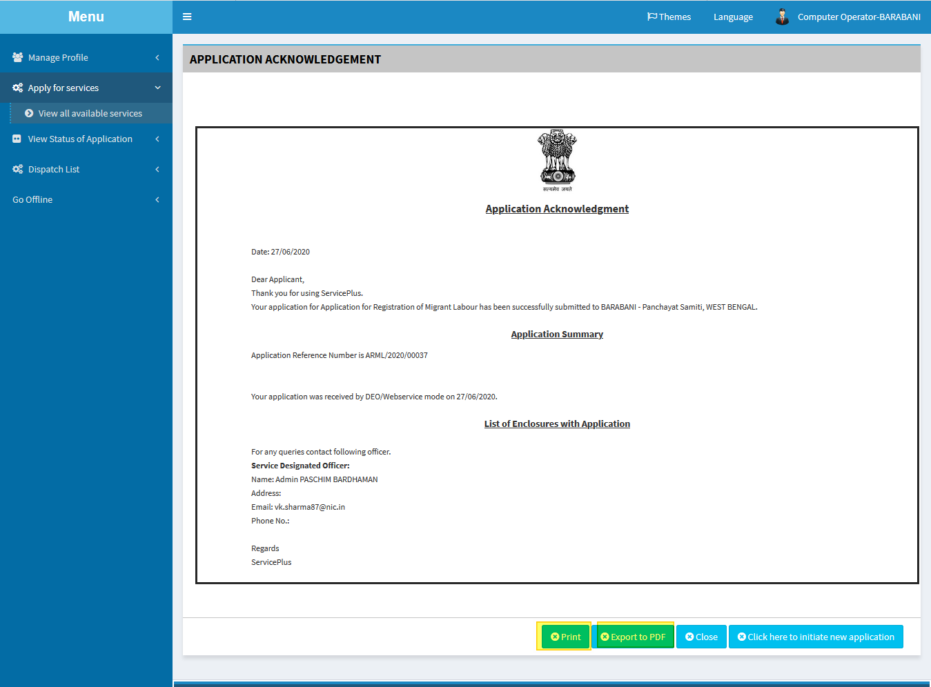

**TRACKING OF APPLICATION**

**Step -1:**

To Track the application we can select “**View Status of Application”** and go to “**Track application status”.**

Here select the appropriate date from to when and it’s optional to give “**app ref no”** to “**get data”.**

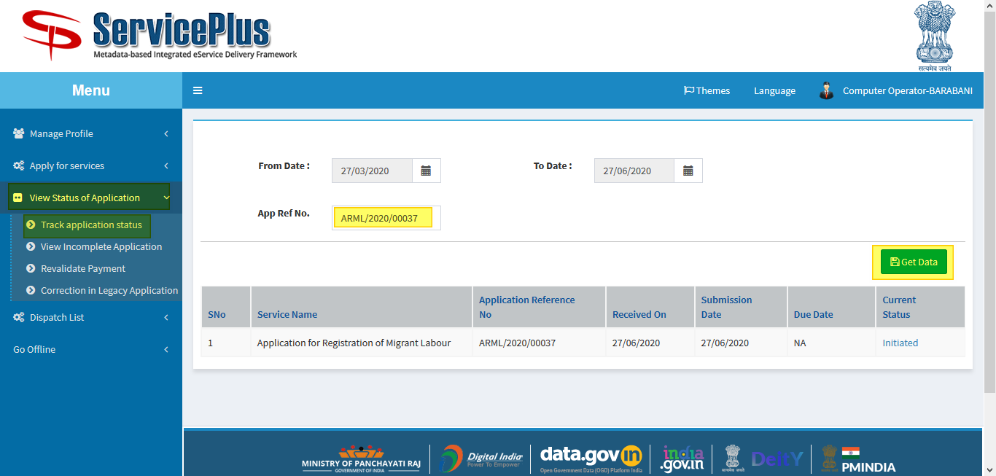

**Step -2:**

Now by getting the application select **“current status”** of the application to keep the track of status of application.

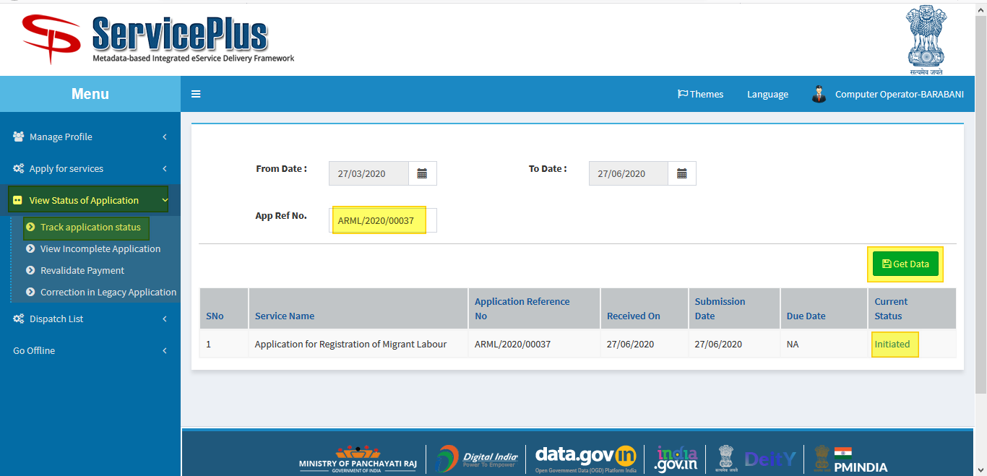

**Step -3:**

Here the application could be **viewed** and **status** could be seen of the application.

